**Step 1**- Login into Office 365 using this link - [**tinyurl.com/t7dphs7**](https://tinyurl.com/t7dphs7)

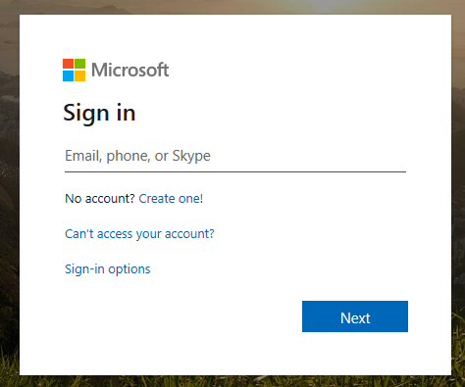

**Step 2**- Enter your user name- 6 digit student [ID@yonkerspublicschools.org](mailto:ID@yonkerspublicschools.org) and click next (Example [876543@yonkerspublicschools.org](mailto:876543@yonkerspublicschools.org))

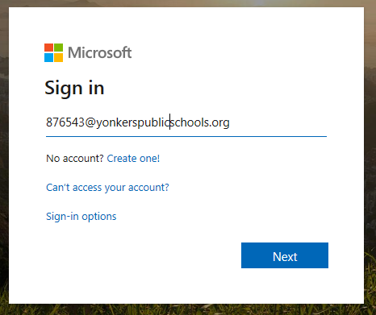

**Step 3**- Enter your windows password. What you use to log into school laptops/desktops. If your password was recently reset, use your 6 digit school ID twice (Ex: 876543876543) and click Sign in

